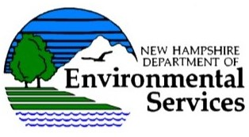

COMMUNITY WATER SYSTEM LEAK DETECTION SURVEY GRANT

The NHDES Drinking Water and Groundwater Bureau is pleased to announce the opening of the grant application period for the 2017/2018 Community Water System Leak Detection Survey Grant. Those applicants awarded a grant will receive a free leak detection survey in 2018.

Application Process:

By 4pm on July 15, 2017:

- Submit this online application Leak Detection Survey Grant Application; and

- E-mail or send to the contact below a copy of the as-built plan or record drawing for the distribution system, with the sections of the system proposed to be surveyed highlighted, and any sections of unknown pipe material type indicated.

Tips:

1. As you cannot fill out part of the application online and go back to it, you are advised to review and/or print out the application so you can gather the information before submitting the application online.

2. If you do not have an accurate plan of the distribution system, please refrain from applying for the grant until a future year when a plan is in place and consider applying for a Public Water System Record Drawing Grant (http://des.nh.gov/organization/divisions/water/dwgb/ under the “Grants/Loans” section.

Contact:

Stacey Herbold
Water Conservation Program
Water Use Registration and Reporting Program
NHDES Drinking Water and Groundwater Bureau
29 Hazen Drive, P.O. Box 95
Concord, NH 03302-0095
PH: (603) 271-6685
FAX: (603) 271-0656

